# Lab 2: Calculations

Academic Honesty

* The work you turn in is to be your work, not copied from someone else, from the web, or generated by a program.
* Never allow anyone access to your files.
* Never give anyone your password.
* Never share your USB memory or email your files to anyone else.
* Never give anyone a printed copy of your file or an electronic copy.
* Never allow anyone to copy your work.

Purpose

This lab will let you practice user input/variables/and simple math

## Part 1 (Fruit Store):

Ask the user for the quantity of each fruit. Then using the listed price of each item, determine the total cost of their bill. Apples (1.49), Bananas (0.39), Kiwi (0.49), Oranges(1.78). Make sure to account for 7% tax.

Your program output should look as follows:

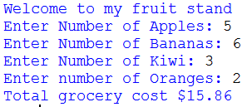

Make sure to pay close attention to spacing, and format so that your result looks just like the sample.

## Rounding

To display your numbers to 2 decimal places you will use the round function.

e.g. print(“…..” + round(num, 2))

This will print the number rounded to 2 decimal places

## Part 2: Speed Calculator

Here you are going to ask the user to enter the time they travelled in hours, minutes, and seconds. Then you will ask for the distance. Knowing that speed = distance / time, calculate the speed they were travelling at. Make sure you round the result before displaying.

### Sample Program below:

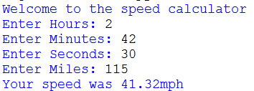

## Submitting your files

* Copy your .py file and move it to your X:\101Labs directory for grading.
* Make sure your files are named Lab2P1XY.py, and Lab2P2XY where XY are your initials
* Print your code, and submit it to your lab instructor at the beginning of your next lab class.

## Grade Breakdown

|  |  |
| --- | --- |
| **Points** | **Expectation** |
| 10% | Comments, listing program and your name |
| 30% | Correctly Gather User Input and assign to variables |
| 30% | Correctly Perform calculations and store result |
| 30% | Correctly display result |